**Article on Alexandra Anna Daddario**

Alexandra Anna Daddario has always wanted to be an actress. For her, acting is not just a career but an avenue to venture into a world of fantasies in which she can detach from reality, scream, freak out and do things unimaginable in real life.

As someone with strikingly blue bold eyes, a sex figure and a person who has been described as stunning, intelligent, creative, loving, she would radiate and dazzle fans as she played the role of Blake Gaines in the 2015 film San Andreas alongside Dwayne Johnson..

Of course, this would not be the first time for she has, behind her, a long list of successes in the entertainment industry ranging from appearances in TV series to exciting starring roles in action movies. However, it was in the San Andreas film that Alexandra stepped formally into the limelight as one of the top actresses in the film industry to look out for in the coming years.

Her co-starring role with Brandon Jackson and Logan Lerman in Percy Jackson movies as Annabeth Chase were precursors to greater things to come. Alexandra further gained attention in the HBO series, True Detective (2014) and in films such as Texas Chainsaw 3D (2013), and Baywatch (2017).

Alexandra in the company of attractive cast of Dwayne Johnson, Kelly Rohrbach and Zac Efron, Kelly Rohrbach were re-engaged earlier on this summer to re-activate the BayWatch TV series on the big screen but indications are that this has not been very successful in the box office. Ever since her debut at the age of 16 she has continued to make great strides in the entertainment industry.

The oldest of three children, Alexandra was born in New York City, New York, to a prominent family on March 16, 1986. Her mother was a lawyer and father a prosecutor. Her paternal grandfather, Emilio Q Daddario was a congressman who represented Connecticut. Her genealogy is a mix of Italian, German English, Irish and Hungarian/Slovak with the father having 75% Italian ancestry. She has a brother, Matthew Daddario, who is also an actor and a star in his own rights.

While a few stars come from families in Hollywood and hence get exposed at an early age to acting, Alexandra comes from a family with political background but nonetheless was determined to be an actress right from the start. She would get the break she wanted in 2002 when she secured a role in a television series *All* *My Children.*

Alexandra, like any other young woman yearns for a perfect love relationship. In her own words, she said “I went to an all-girls school for part of high school, and the idea of boys was amazing to me. Like, all I ever wanted to do was kiss boys and be around boys”.

She was last associated with Logan Lerman, a co-star in Percy Jackson. However, she has of late been seen hanging out with Zac Efron, another co-star, but this time in the Baywatch TV series; prompting a rumour that romance is in the air. Alexandra is 32 while Zac is 30 but together they have been described as a lovely couple.

They have also been spotted recently in Los Angeles shopping together with their dogs. In addition, probably to excite further interests of the public, they have been seen in the streets of Los Angeles laughing, talking and embracing each other. On Alexandra’s birthday, Zac Efron posted a heart-warming tribute to Alexandria on Instagram.



**Alexandra with Zac Efron Shoping for Dog Supplies**

While the exact status of their relationship is unclear, it is sure stirring up great expectations on the part of the fans, but wait a minute: Why is she dating only co-stars? In an interview with PEOPLE in Los Angeles she reveals that: “It feels really surreal — as a teenager I could never really get guys and I was pretty nerdy. Now I feel like I’m getting my revenge by being a *Baywatch* babe. I’m like, ‘You could have had this and now look at me”.

Alexandra is not without a fair share of scandalous stories associated with her. She has been quoted as saying in public that the scene that featured her [co-star's erect penis](https://www.express.co.uk/entertainment/films/809345/Baywatch-movie-penis-The-Rock-Zac-Efron-Alexandra-Daddario-Kelly-Rohrback) was the main factor that convinced her to sign up for the Baywatch movie. She also revealed in an interview with BBC Radio 1 that she was accused of wetting the bed in the hotel she stayed while filming the Baywatch movie and had to pay an extra bill to remove the stains.





**In the Hotel Room**

In a mouth-watering display of her nipples and the rest of her body, Alexandra was exceptional in a crowd of fellow stars at last Wednesday night’s Dior Addict Lacquer Plump event in Los Angeles Poppy nightclub and lounge in which she appeared in a braless under sheer off-the-shoulder dress.

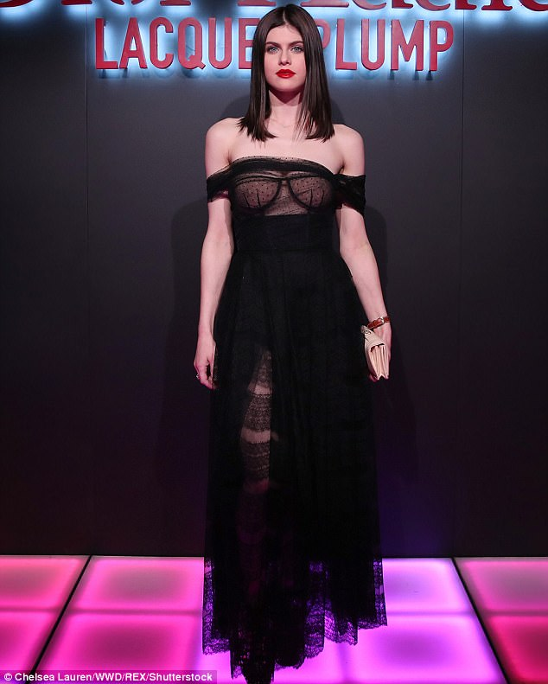

**In Los Angeles Poppy nightclub and lounge**

However, there are many sides to her personality. Alexandra is compassionate, idealistic and willing to use her stardom status to benefit less fortunate people particularly those in the Third World. She has followed in the footsteps of her role model Elizabeth Taylor and acts as an emissary for the development of new partnerships between [The Elizabeth Taylor Aids Foundation](https://elizabethtayloraidsfoundation.org/) and the United *Nations* [*Nothing But Nets*](https://nothingbutnets.net/) campaign.

She was in Malawi recently promote the UN’s efforts to provide testing and treatment for HIV/AIDS and Malaria patients witnessing first-hand how The Elizabeth Taylor AIDS Foundation and the [Global AIDS Interfaith Alliance](http://www.thegaia.org/) (GAIA)’s mobile health clinics are changing the lives of over 600,000 people in Malawi. At a tender age of 32, Alexander’s star is just rising. The world will surely hear from her again.

<p>&nbsp; &nbsp;</p>
                    

**In Malawi**